Technische fiche aluminium deksels

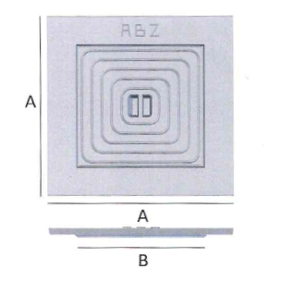
Enkele deksels

 | A  Buitenmaat | B  Nuttige opening
200 x 200 mm | 200 mm | 115 mm
300 x 300 mm | 300 mm | 180 mm
400 x 400 mm | 400 mm | 280 mm
500 x 500 mm | 500 mm | 380 mm
600 x 600 mm | 600 mm | 476 mm
700 x 700 mm | 700 mm | 576 mm

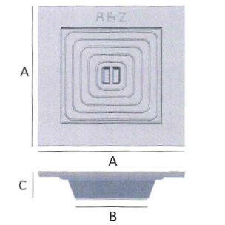
Dubbele deksels

 | A  Buitenmaat | B  Nuttige opening | C  Hoogte
200 x 200 mm | 200 mm | 80 mm | 60 mm
300 x 300 mm | 300 mm | 135 mm | 60 mm
400 x 400 mm | 400 mm | 235 mm | 60 mm
500 x 500 mm | 500 mm | 335 mm | 60 mm
600 x 600 mm | 600 mm | 435 mm | 60 mm
700 x 700 mm | 700 mm | 535 mm | 60 mm

